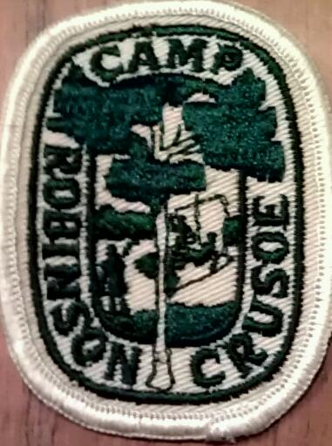

ALUMNI GATHERING/DOCUMENTARY SING-A-LONG
Sturbridge, Massachusetts

October 28, 2012

CAMP ROBINSON CRUSOE
LYRIC SHEETS

Prepared by Tom Greenfield

This Land is Your Land 2
If I Had a Hammer 3
Michael, Row the Boat Ashore 4

Kumbaya 5
Swing Low, Sweet Chariot 6
Good Night, Irene 7

THIS LAND IS YOUR LAND

CHORUS:

This land is your land, this land is my land
From California to the New York Island
From the Redwood forest to the Gulf Stream Waters
This land was made for you and me

As I went walking that ribbon of highway
I saw above me that endless skyway
I saw below me that golden valley
This land was made for you and me

Chorus

I roamed and rambled and I followed my footsteps
To the sparkling sands of her diamond deserts
And all a-round me a voice was sounding
This land was made for you and me

Chorus

As I went walking, I saw a sign there,
And on the sign it said "No Trespassing."
But on the other side the sign said nothing,
That side was made for you and me.

Chorus

IF I HAD A HAMMER

If I had a hammer,
I'd hammer in the morning
I'd hammer in the evening
all over this land,

I'd hammer out danger
I'd hammer out a warning
I'd hammer out love between my brothers and my sisters
All over this land.

If I had a bell
I'd ring it in the morning
I'd ring it in the evening
All over this land,
I'd ring out danger
I'd ring out a warning
I'd ring out love between my brothers and my sisters
All over this land.

If I had a song
I'd sing it in the morning
I'd sing it in the evening
all over this world,
I'd sing out danger
I'd sing out a warning
I'd sing out love between my brothers and my sisters
All over this land.

Now I've got a hammer
And I've got a bell
And I've got a song to sing
all over this land,
It's a hammer of justice
It's a bell of freedom
It's a song about love between my brothers and my sisters
All over this land.

(Last verse Repeated)
It's a hammer of justice
It's a bell of freedom
It's a song about love between my brothers and my sister/All over this land.

MICHAEL ROW THE BOAT ASHORE*

Michael row the boat ashore, hallelujah
Michael row the boat ashore, hallelujah

Sister help to trim the sails, hallelujah
Sister help to trim the sails, hallelujah

The river is deep and the river is wide, hallelujah
Milk and honey on the other side, hallelujah

Jordan's river is chilly and cold, hallelujah
Chills the body but not the soul, hallelujah
Michael row the boat ashore, hallelujah
Michael row the boat ashore, hallelujah

* Pete Seeger generally sings THE boat rather than YOUR boat.
KUMBAYA
Kumbaya my Lord, kumbaya
Kumbaya my Lord, kumbaya
Kumbaya my Lord, kumbaya
Oh Lord, kumbaya

Someone's singing Lord, kumbaya
Someone's singing Lord, kumbaya
Someone's singing Lord, kumbaya
Oh Lord, kumbayah

Someone's laughing, Lord, kumbaya
Someone's laughing, Lord, kumbaya
Someone's laughing, Lord, kumbaya
Oh Lord, kumbaya

Someone's crying, Lord, kumbaya
Someone's crying, Lord, kumbaya
Someone's crying, Lord, kumbaya
Oh Lord, kumbaya

Someone's praying, Lord, kumbaya
Someone's praying, Lord, kumbaya
Someone's praying, Lord, kumbaya
Oh Lord, kumbaya

Someone's sleeping, Lord, kumbaya
Someone's sleeping, Lord, kumbaya
Someone's sleeping, Lord, kumbaya

Kumbaya my Lord, kumbaya
Kumbaya my Lord, kumbaya
Kumbaya my Lord, kumbaya
(Rit) Oh Lord, kumbaya

SWING LOW, SWEET CHARIOT

Chorus Swing low, sweet chariot
Coming for to carry me home,
Swing low, sweet chariot,
Coming for to carry me home.

I looked over Jordan, and what did I see
Coming for to carry me home?
A band of angels coming after me,
Coming for to carry me home.

Chorus

Sometimes I'm up, and sometimes I'm down,
(Coming for to carry me home)
But still my soul feels heavenly bound.
(Coming for to carry me home)

Chorus

If you get there before I do,
(Coming for to carry me home)
Tell all my friends I'm coming too.
(Coming for to carry me home)

Chorus.

GOOD NIGHT, IRENE

CHORUS:
IRENE GOOD NIGHT, IRENE GOOD NIGHT

GOOD NIGHT IRENE, GOOD NIGHT IRENE

I’LL SEE YOU IN MY DREAMS

LAST SATURDAY NIGHT I GOT MARRIED
ME AND MY WIFE SETTLED DOWN
NOW ME AND MY WIFE ARE PARTED
GONNA TAKE ANOTHER STROLL DOWNTOWN

CHORUS

SOMETIMES I LIVE IN THE COUNTRY
SOMETIMES I LIVE IN TOWN
SOMETIMES I TAKE A GREAT NOTION
TO JUMP INTO THE RIVER AND DROWN
CHORUS
(SLIGHTLY SLOWER)
GOOD NIGHT IRENE, GOOD NIGHT IRENE
I’LL SEE YOU IN MY DREAMS

